**Oracle Client Installation:**

1. **Execute setup for client select Administrator**

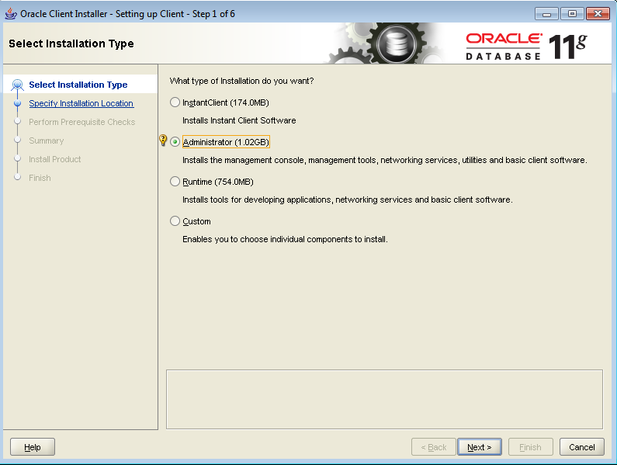

1. **Select Language English as default:**

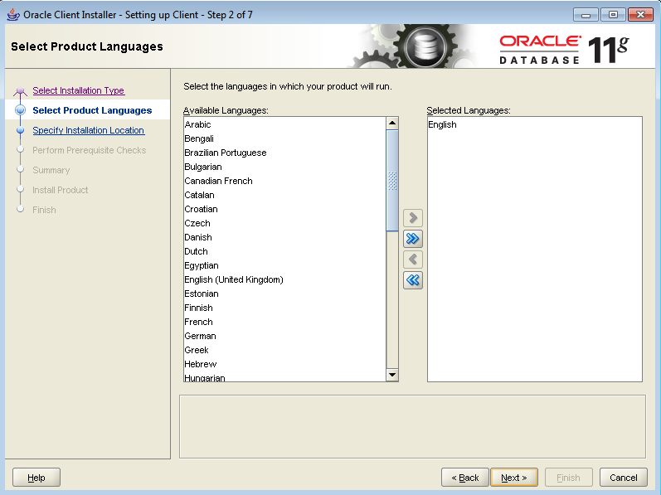

1. **Select the path**

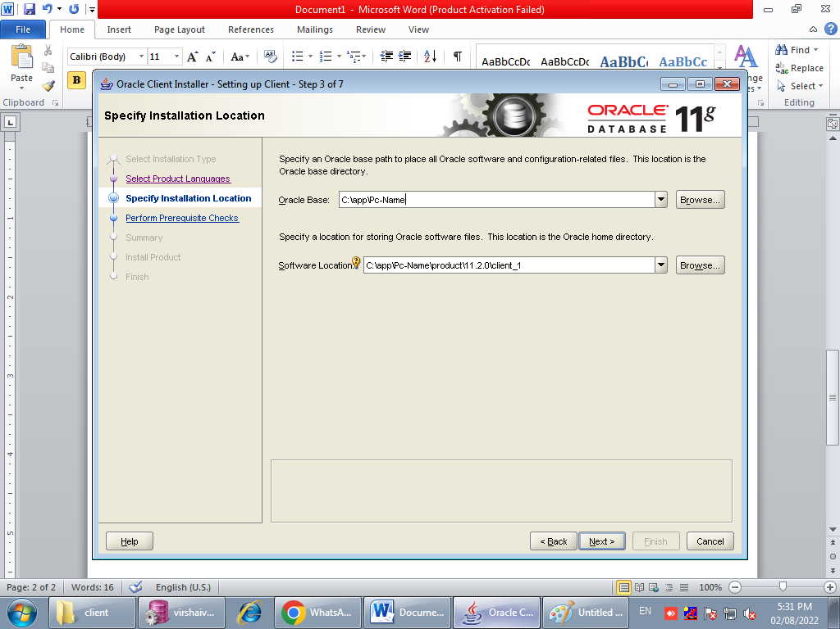

1. **Verifying the minimum installation:**

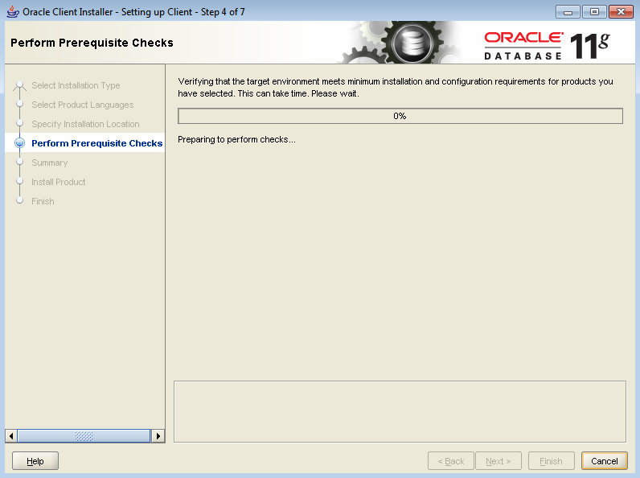

1. **Click on finish**

